Task1: Log into the WLC

Log into the WLC_PORTFOLIO_2.0/_Cross_Technology/CCNA_Unified/CCNA/v1.0/v1.0/ELT_Videos/CCNA100_25-6_Log_Into_WLC_001.mp43Play Transcript ID4174558template_version4.1.1_PORTFOLIO_2.0/_Cross_Technology/CCNA_Unified/CCNA/v1.0/v1.0/ELT_Videos/CCNA100_25-6_Log_Into_WLC_001.vtt

In this task, you will have the opportunity to configure a Cisco WLC Web using the GUI. There may be a situation where you need to deploy a new WLC to support a new office, a new floor, or a new remote location.

There are two methods of configuring the WLC, from the GUI and from the CLI through the console connection on the WLC. Both are very effective; in some special cases, you may need to use both configuration methods to perform different configuration steps. In this activity, you will only need the GUI to perform the configuration steps.

You will use Cisco 3504 WLC, which is intended for small to medium-sized enterprise networks and branch offices. At your job, you might encounter other WLCs that have slightly different GUIs, however the core functionality remains the same.

* **Procedure1:**

To begin the process, you will need some credentials to access the WLC. The username is **admin**, and the password is **Cisco123**.

CLOSE TIP

**Note**

Remember that the username and password are *case sensitive*. One other thing to remember is that if you add a new username to the WLC, the password *must contain* uppercase and lowercase letters, a number, and a special character.

* **Procedure2:**

Open the Chrome browser on your PC.

CLOSE TIP

Click the **Chrome** browser icon.

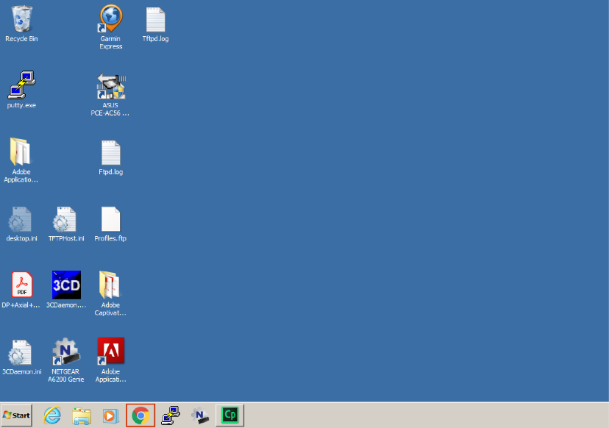

* **Procedure3:**

Use the IPv4 address to log in to the WLC. Type **https://192.168.1.150** in the address bar, and press **Enter**.

CLOSE TIP

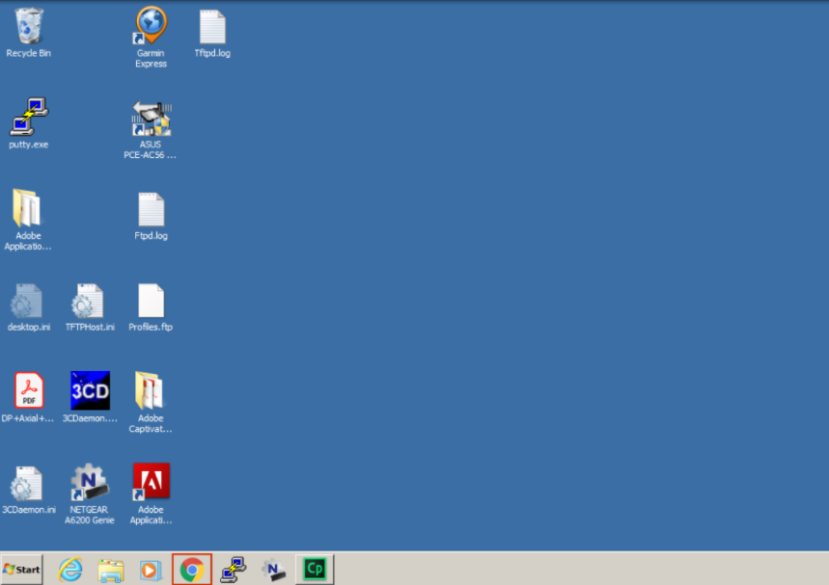

* **Procedure4:**

The opening screen from the WLC will appear. Log in to the WLC.

CLOSE TIP

Click the **Login** button in the middle of the screen.

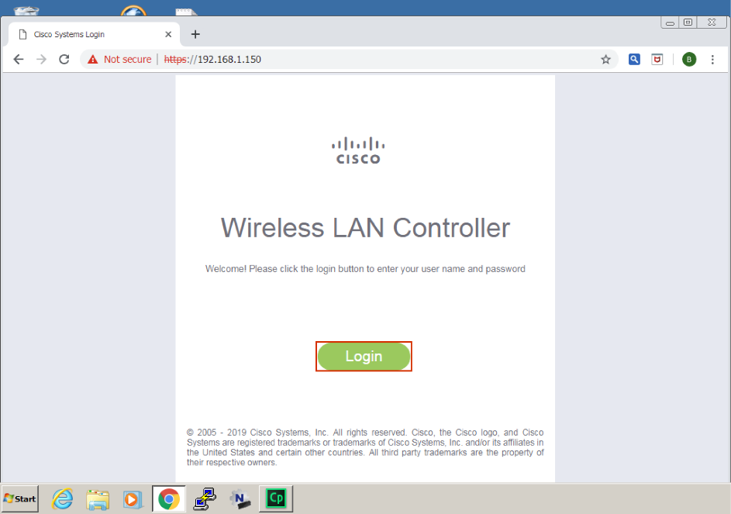

**Note**

Notice the Not Secure warning next to the URL bar and the crossed out https. Usually, when you see something like this to your HTTPS URL, this may indicate that there is a problem with the certificate of the website that you are trying to reach. The certificate may have been expired or it may not have been signed by one of the certificate authorities (CAs) that the browser implicitly trusts. However, in this case, it is more likely that this warning is a result of the password input field. As of January 2017, Google Chrome marks all the pages that include a non-secure password field with a Not Secure warning. Even if the top-level page is HTTPS, the warning will appear if the password input frame is not served over HTTPS as well.

* **Procedure5:**

A dialog box will appear at the top of the screen where you can enter your credentials. Use the **admin**/**Cisco123** credentials. Both username and password are case-sensitive. Type carefully, and press **Enter** when finished.

CLOSE TIP

**Note**

The characters in the password are not displayed, only dots will be displayed.

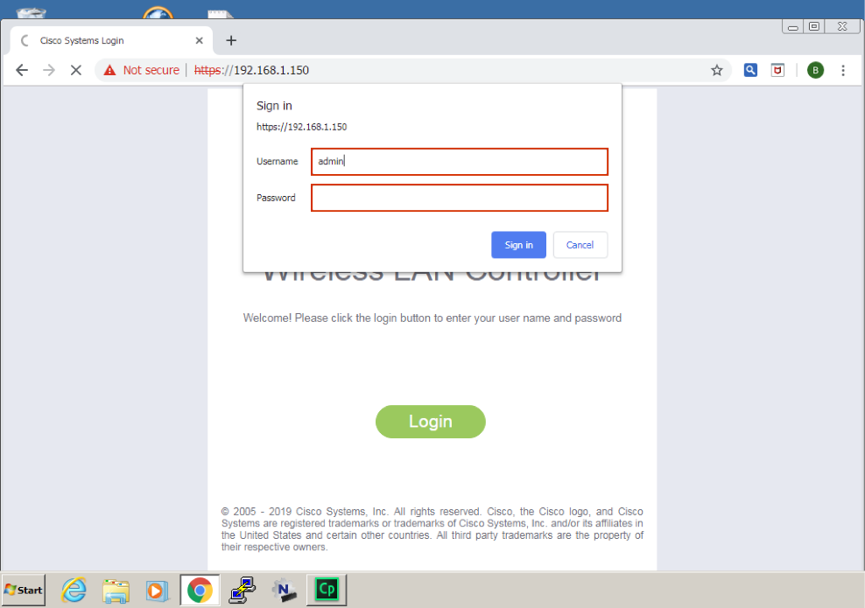

* **Procedure6:**

Observe the initial Network Summary WLC screen.

CLOSE TIP

The opening screen of the WLC will appear. There is a lot of information you can see on this screen, but understand that this screen is a summary screen. You don?t have the ability to make configuration changes from this screen, you can only look at what the WLC is reporting.

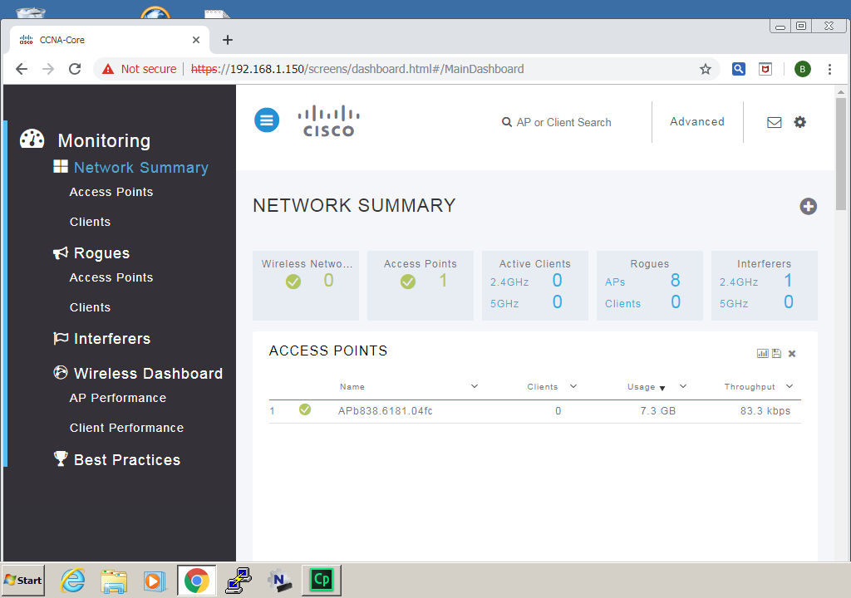

* **Procedure7:**

Navigate to the **Network Summary** screen, by going to the top right corner of the Network Summary page and click **Advanced**.

CLOSE TIP

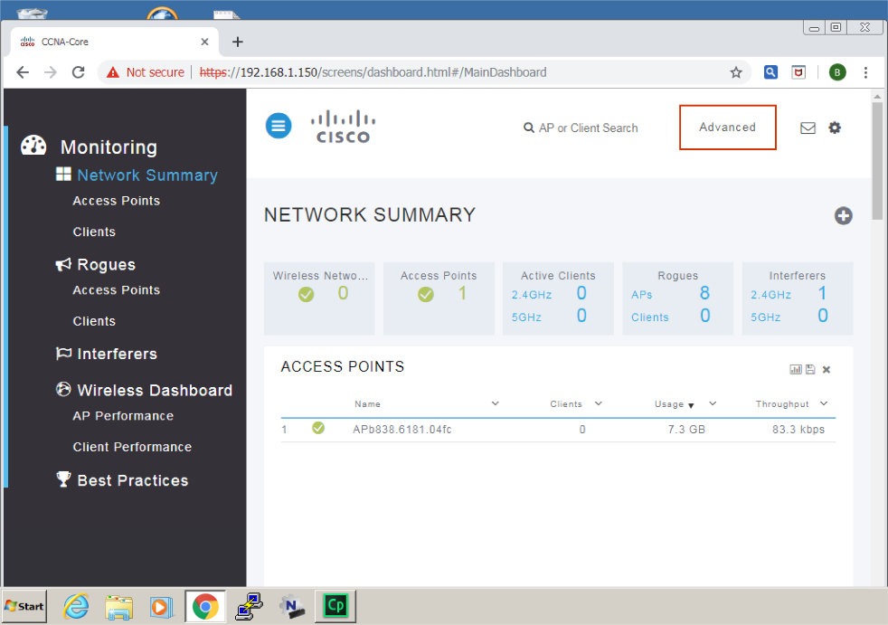

The next screen you see is the Monitor Summary screen. This view is much different from the Network Summary screen. You will use the menu options on this screen and others to configure the WLC in other discoveries. If you need to validate that an AP or a client has joined a WLAN, the Monitor screen is a good place to start troubleshooting issues.

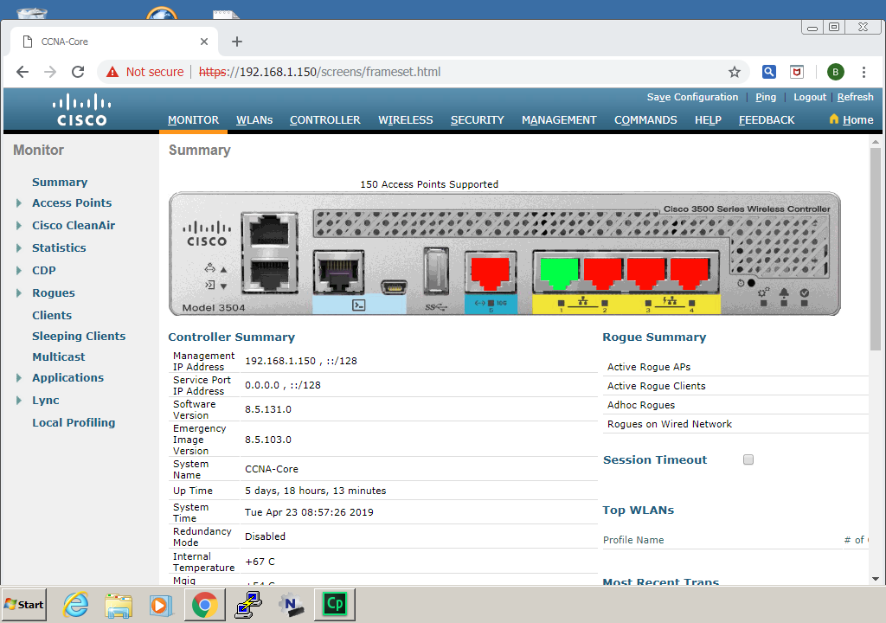

* **Procedure8:**

You have completed this activity when you have attained these results:

* + You have used Chrome to connect to the WLC.
  + You have entered the credentials to access the WLC GUI.
  + You have entered the Network Summary screen.
  + You have navigated to the Advanced Monitor Summary screen.